Core|Recruitment: Automated email notifications

Contents
Document Version Control 1
Approved process for raising 2
Consultation & Approval 2
Change Management 2
How to 3
Testing 6
Communications 6
Downstream Systems & Processes 7
Affected Reports 7
Additional Background Information 7

Document Version Control
Change History/Review Details
Date | Version | Review by | Summary of Change
29/8/17 | 0.1 | HC | Basic Draft
3jan19 | 0.1 | HC | Further details added
01-NOV-2019 | 1.0 | SB | Link to the EMS configuration following clone document added for reference.
3 Oct 2023 | 2.0 | HC | Updated following changes to the email settings and to reflect portal processes

Approved process for raising
Does the change need to be raised through a particular route or by a particular person/team? Are there any actions which need to be taken or considered prior to processing in the HRIS Support Centre?
A request for change could come from any source and may be the result of legislative changes or a Business Requirement. Any changes must follow the Change Management process in force at the time of the change.

Changes may need to be presented at HRSEG for agreement before being implemented.

The University’s central recruitment team within Personnel Services may need to be consulted about any changes to the Applicant notifications.

Consultation & Approval
Who is the owner of this information? Who needs to be consulted about this change before you begin work on it? Does anyone need to approve this change before it is implemented?
This will vary according to the type of event/notification. A guide is included below:

Applicant
HR Policy
Head of Recruitment

Auto-enrolment
Head of Pensions

Vacancy
Head of Recruitment

Staff Request
HRSEG
Reward Team

ESS notifications

Change Management
What type of change is this? When should approval be sought and from whom (internal to team or change manager)? Who would normally be responsible for implementing?
Approval should be sought from the relevant stakeholder(s) prior to the change being made.

The system changes must be approved by the System Owner (the Head of HRIS Support) or their nominated deputy, via the change request in HEAT, ideally before implementation.

The HRIS Support Centre will be responsible for implementing the change.

How to
Technically how to process the change in the system
Adding a new ….
Navigate to: CoreHR > Event Management > Hr Event Configuration

Draft process, not tested

- To add a new notification to an existing event select the Event Category and Event Type and click Edit. The Maintenance window will open.

- Click on Add New Notification. The Event Notification maintenance window will open.

- Enter the required details and click on the Save Changes button.

Changing a ….
Navigate to: CoreHR > Event Management > Hr Event Configuration

- To edit an existing event notification, select the Event Category and Event Type and click Edit. The Maintenance window will open.

- Click on the Edit button next to the notification you wish to amend. The Event Notification maintenance window will open.

- Edit/update as required and click on the Save Changes button.

Removing a ….
Navigate to: CoreHR > Event Management > Hr Event Configuration

Draft process, not tested

- To delete an existing event notification, select the Event Category and Event Type and click Edit. The Maintenance window will open.

- Click on the Edit button next to the notification you wish to amend. The Event Notification maintenance window will open.

- Click on the Delete button at the bottom of the screen.

View the email notifications
- To view the current set up, navigate to People Management > HR Admin Setup settings > Event management > Hr Event Configuration:

  - Select the Event Category

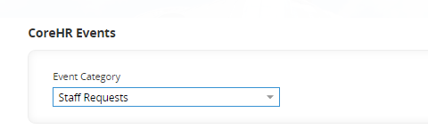

  - Click on EDIT next to the Event Type you wish to view

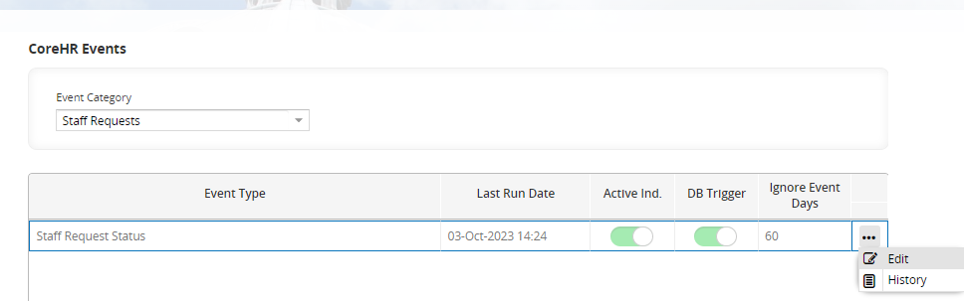

  - Click on EDIT next to the Event Notification you wish to view

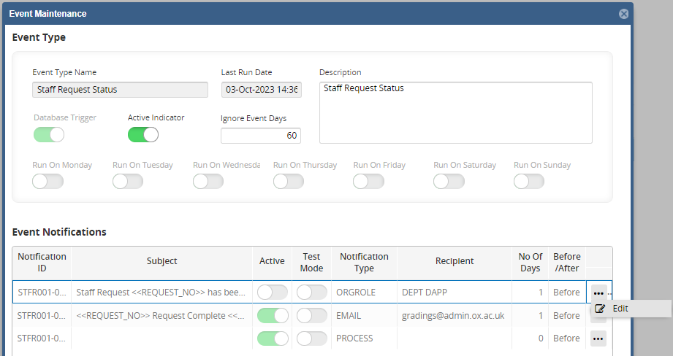

- To view the emails generated, navigate to People Management > People Management > View Email Queue.

  - All emails are displayed in the queue (including those generated by departments) in date order.

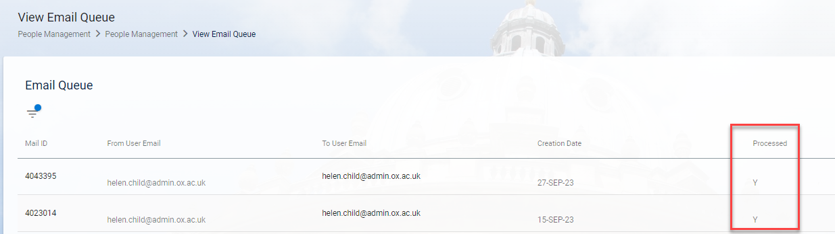

  - A tick in the ‘Processed’ column means that the mail has been sent.

  - A limited search option is available to narrow down the list if you are looking for a particular date range or recipient.

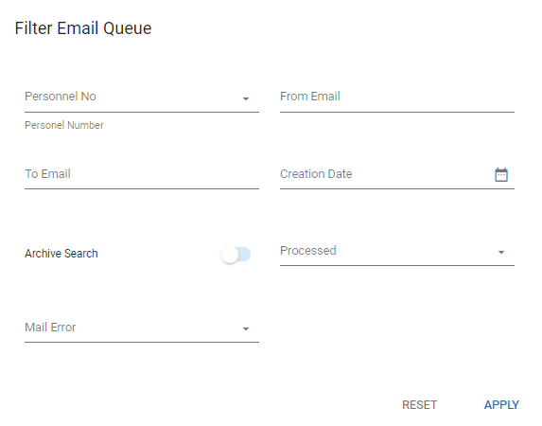

  - Enter your search criteria and click on APPLY.

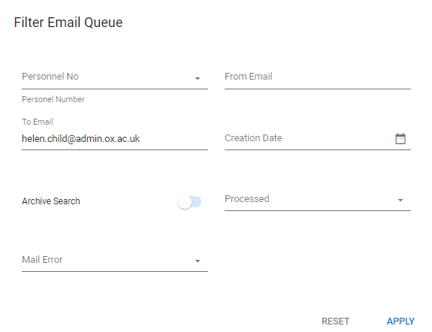

  - To start a new search, click on RESET and then enter new criteria.

- View when vacancy notification emails were last sent, navigate to Personnel > Recruitment > Recruitment Reference > ERecruitment Web Parameters … General Parameters.

  - In the Applicant Notifications section check the dates in the Creation Last Date Run and Sending Last Date Run boxes. In most cases the dates should be the same although the actual time will differ.

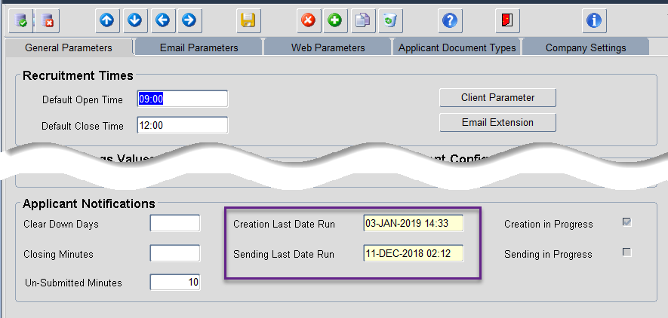

Standard Icons & Terminology
Standard Button Names  Enter Query Mode button:  Previous Record button:   Previous Section button:   Save button:   Insert Record button:  | Execute Query button: 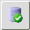  Next Record button:   Next Section button:   LOV button:   Delete Record button:  | Cancel Query button: 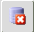  Red Door button: 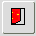  Duplicate Record button: 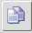
Navigation Paths

Show the final navigation path option in bold+italics, for example;

Core|Personnel > Reference > Reference A – C > Accident Codes
Core|Pay > Reference > Pay Groups

Any further navigation beyond the navigation path can be added after an ellipsis (…), for example;

Event Management > Event Configuration … HR Events > Change of Address

Other Standard Terminology

Testing
Who would normally be responsible for testing? Are there standard items to test?
HR Systems will be responsible for carrying out initial testing but it may also be necessary for others to take part in further testing.

Testing should include checking that:

The email is created at the appropriate time i.e. triggered by the event it is linked to
The email is sent to the specified recipient(s)
The email is received by the specified recipient(s)

Further information about EMS settings in test environments can be found in the Email and Event Configuration following a clone document.

Communications
Who needs to be informed (but not consulted) about this change? Detail when they should be informed (before or after the change).
Departmental users will need to be informed if they are affected by the changes. This could be an announcement in the monthly bulletin or by email either before or after the change has been made.

Downstream Systems & Processes
Details of any processes which are affected or need to be carried out following, or as part of, the change. Please detail any triggers, actions required and when the actions should be carried out.
QRGs may need to be updated following the changes.

Affected Reports
Are there any standard reports which may need to be updated following this change?
No reports are affected.

Additional Background Information
Any other relevant information, links to supporting documentation etc.
Email settings
Details of the current email settings can be found in the Email Settings document.

The default mailbox is HRIS.MAILRETURN@IT.OX.AC.UK from which the automated emails are sent.

Details of the events and automated emails can be found in the Events and Notifications log here. Refer to the ‘Full Details’ tab or ‘Applicant Notifications’ tab.

Further information about EMS settings in test environments can be found in the Email and Event Configuration following a clone document.

Events
Automated email notifications are generated from CoreHR based on specific Events created in the system. The settings within the event determine when the emails are triggered. An event can have a single or multiple emails linked to it.

To view the individual events and notifications see the ‘How To..’ section above.

(NB this article does not include emails that can be generated manually by departments e.g. when communicating with applicants about a specific vacancy)

Email types

Applicants
Emails are automatically generated to applicants and potential applicants under the following circumstances:

- When changes are made to an applicant (portal) account
- When an application has been submitted for a vacancy

Applicant Portal Users
- When vacancies meeting specified criteria are opened for advertising.
- When a new password is requested

The vacancy notification is slightly different as the emails are sent once a day rather than immediately after it has been triggered by the event. A job runs at regular intervals through the day to generate the emails which are then stored to be sent later. A creation job runs to gather all of the emails to be sent and then the send job runs to send the emails.

These jobs often fail, especially after the system has been taken down for patching or upgrades. We have experimented with various timings of these jobs and at the present time there is a 2 hour delay between the creation and send jobs. The job names are as follows:

pers_applicant_notify_pack.create_notifications
pers_applicant_notify_pack.send_emails
If the jobs fail a call will need to be raised with Access group to restart them

Job Name | Purpose | Frequency
EMS_MAILER_Q.GENERATE_EMAIL | Gather vacancies opened in the last 10 mins | Every 10 mins
pers_applicant_notify_pack.create_notifications | Collate the emails created by the above job | Daily
pers_applicant_notify_pack.send_emails | Send collated notification | Daily

There is also an open Problem Record - 40000869.

Vacancy Notifications.

Emails are automatically generated to departmental users for the following reasons:
- When applicant packs are generated for a vacancy (job completed)
- When merged packs are generated for a vacancy (job completed)

Staff Request notifications

Emails are automatically generated to departmental users for the following reasons:
- When a staff request has been submitted for approval (to relevant approvers)
- When a staff requested has been processed to completion by the Reward Team

Auto-Enrolment

The auto enrolment routine runs once a month after the final payroll run has been completed. There are pre-set criteria within the auto-enrolment process, details of which can be found in the auto-enrolment configuration document here.

Emails will be sent to individuals for the following reasons:
- When an employee has been Assessed But Postponed (possibly because their earnings on the relevant appointment have not yet reached the minimum contribution value)
- When an employee has been Auto Enrolled
- When an individual’s appointment is not eligible
- When an employee has chosen to opt out

Issues

Sometimes an email notification is blank or fails to send completely.

Unrecognised character entered on the staff request. Staff Request completion notifications sometime fail to send if there is a special character such as a dash or hyphen in a free text field or within the title of an attachment on the staff request. Some testing has been carried out on this issue but we have not been able to determine exactly which characters can and can’t be used.

Too much text in the additional information box. Although the text was within specified character limits - see Incident 10318226

